C:\Users\twilliams\Desktop\asanacrescent2.png

# Purpose

The purpose of this document is to guide new and potential users on how to use Asana Crescent

# What is Asana Crescent?

Asana Crescent is a reporting application that has the capability to extract raw data from asana and generate reports based on the user’s preferences

# What can be done with Asana Crescent?

* Asana Crescent can be most useful for times when the user may wish to generate reports for any or all of the project categories available on Asana.
* These reports are automatically generated as tables in Microsoft’s Excel.
* Once generated, the user will be free to manipulate the data via excel in any way they desire, whether that be by:
  + Pivot Tables
  + Graphs
  + Other alternative data representations

# How to use Asana Crescent:

1. To use Asana Crescent, begin by double -clicking on the “**AsanaCrescent.exe**” executable file



1. Once that is done, the program will begin and will immediately request your Asana **API key**

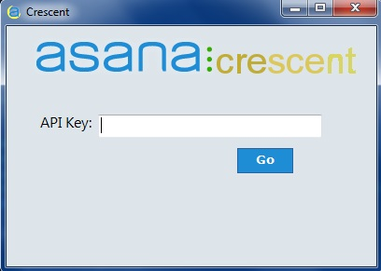

* 1. In order to obtain your personal API Key:
     1. Log in to your asana account
     2. Select your “**Account Settings**” on the bottom left screen

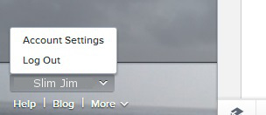

* + 1. From the menu, select the “**Apps**” tab

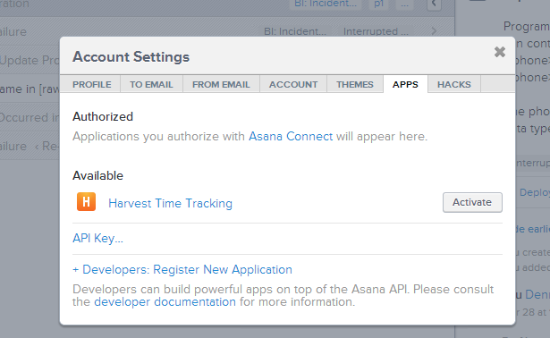

* + 1. Click on “**API Key…**”

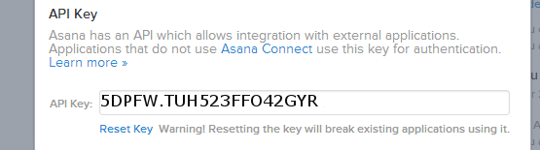

* + 1. You will see a long list of numbers and letters, copy that list and then paste it into the program

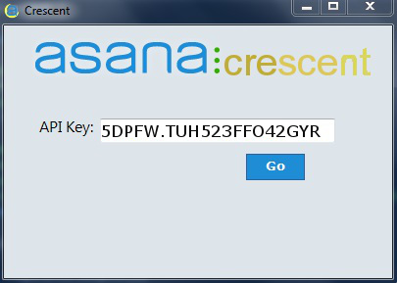

* + 1. Hit “**Go**” once this is done

1. Next, you may choose your workspace.

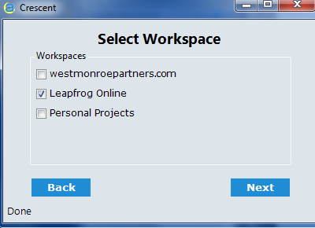

* 1. For Leapfrog Online Reporting purposes, the user just needs to select the “Leapfrog Online” workspace

1. Once you’ve selected your workspace, every project associated in that workspace will populate.

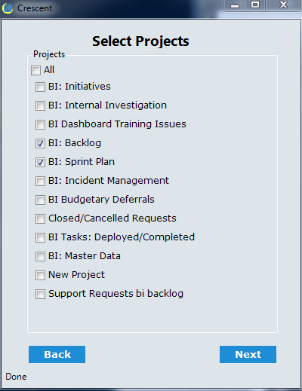

* 1. Selecting any or all of the projects will allow the user to further narrow down which tasks they would like to use to build a report

1. When projects have been selected, each task associated with that project will populate

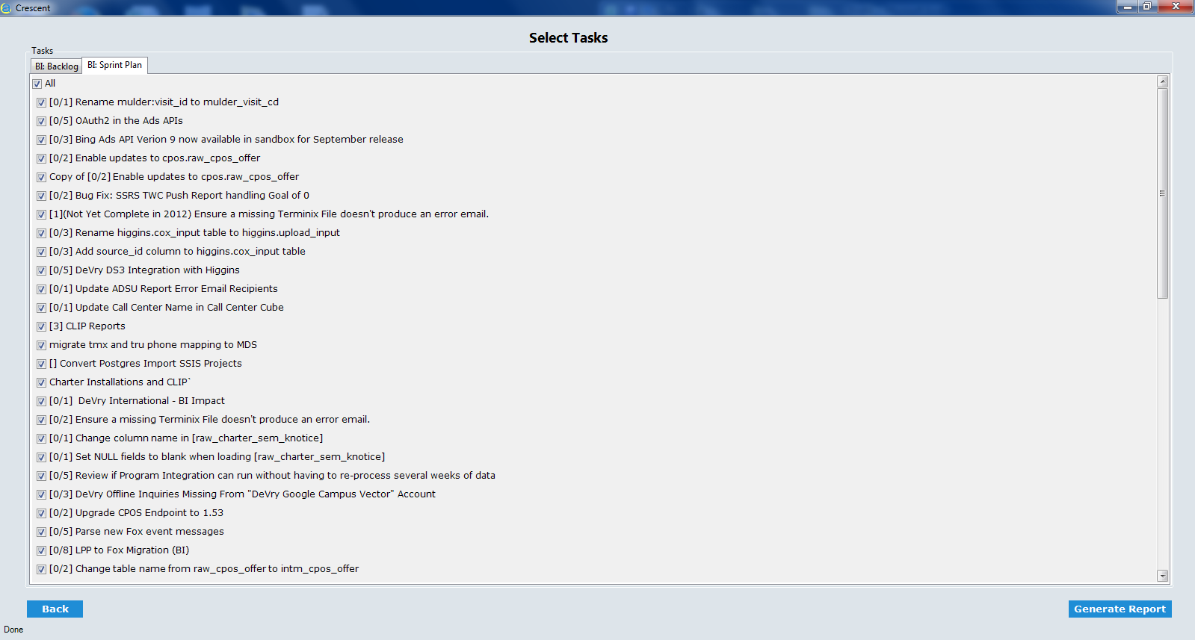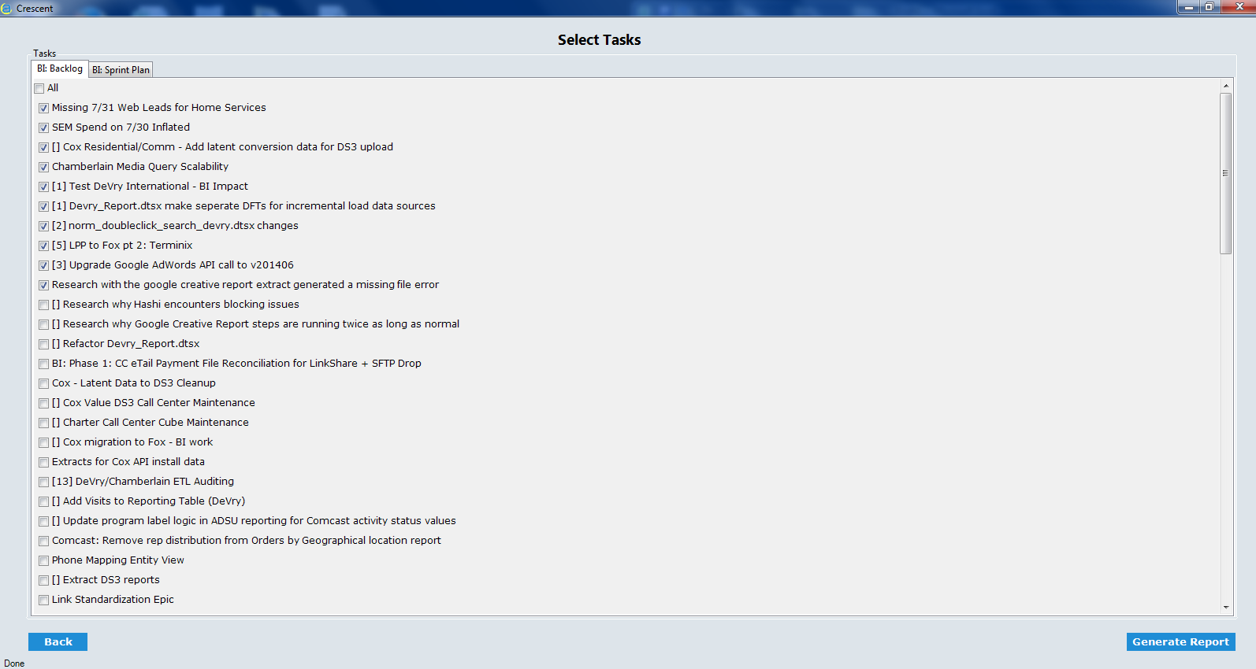

* 1. The user will have the opportunity to select all tasks for a project, or specific ones

1. Once all tasks have been selected click “**Generate Report**”
   1. Report generation time varies based on how many tasks are being reported on



1. Asana Crescent will generate its reports in the same location in which the executable file is located
2. Once the report is generated



* 1. All of the data within a report is automatically formatted into a table
  2. If the report was built off of multiple projects, a new worksheet and table will populate for every chosen project